Connected Services

Objective:
We want to be able to cater to the increasing market demand for connecting services. Currently as well there are connected services being hosted on redbus but while booking users are often not aware that they are booking a connected service. The idea of this story is to set the right expectations for the user by providing them the information regarding change of service & layover time. This would in turn cover a larger market for us which translates to increase in the business.

Metrics:
- CR for connected S-Ds
- DRR for connected service bookings
- # of connected services hosted on the platform
- #Customer contacts

Design:
https://www.figma.com/file/hiaBc6GUU9rM57D5r8TrQw/Q3-India-2023-2024?type=design&node-id=3064%3A254426&mode=design&t=Y8F3M7EMEWaIgAJW-1

https://www.figma.com/file/teRp8PZbGfyaVumlf77S9m/%F0%9F%87%AE%F0%9F%87%B3-Q4-INDIA-2023-2024?type=design&node-id=575-2&mode=design&t=9tFFeCMdLIW6hRvn-0

Tech Documentation :

https://docs.google.com/document/d/1IEWAKTbNARGJiuynxpYUvuNxRXKpRajrSvnyLCaeit4/edit#heading=h.m8a8h6p0z618

Description:

As a part of this story (B2C), we would plan to make the following changes:

SRP
Highlight on the SRP that the user is booking a connected service. The following information to be shown on SRP tuple
- Layover duration
- Layover City
- We would not any redDeal manifestation on the SRP, however we would show the post discount price on the SRP
- Reddeal configured for A-C should be shown on the SRP
- The rating on the tuple:
We would show the aggregate rating at BO level
We would show the rating for the connected service (for connected service service ID)
- In case when a service is reaching on Day +2 - highlight it with a tag
- Design would also have 2 bus types for both those legs like shown
- Price shown on the SRP tuple would be
Min (price in 1st leg) + Min (price in 2nd leg) * multiplication factor
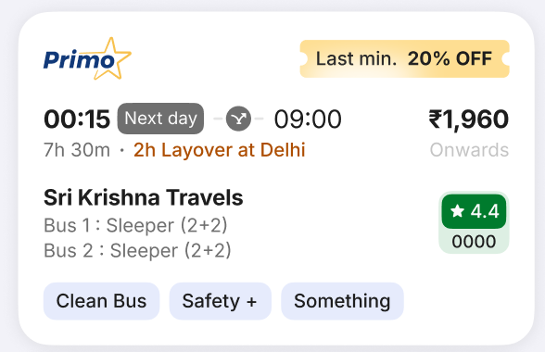

- In case a service has non compatible seats on both of the legs, it must NOT be shown on the SRP.
Example: If 1st leg has only reserved for Male and 2nd leg has only reserved for female seats - then the service must not show up on the SRP

How would filters work:
If a user applies a certain filter (Example: AC or sleeper etc) - then a service would show up if both of the legs fall in the filter category.
Example: If a connected service consists of AC and Non AC service, then this service should not appear when the user applies AC filter or non AC filter.

Tuple click:
Bottom sheet / layer on the SL to educate the user that the service is a connecting service.
This bottom sheet to have the following components:
- BO name
- Bus types for both the legs (added in the design)
- Source city & boarding time
- Boarding point (in case of BP-DP/ BP-City search)
- Layover dropping point & dropping time
- Layover boarding point & boarding time
- Dropping point (in case of BP-DP/ City-DP search)
- Destination city & dropping time
- Layover duration
- Lounge details - this won’t be a part of phase 1
- Duration for both the legs
- Whether the operator would give transportation from layover DP and layover BP

Closing the bottom sheet should take the user to SRP again
(The screenshot shown is for BP-DP search. The BP/DP names would be replaced by city city if the search is broad)
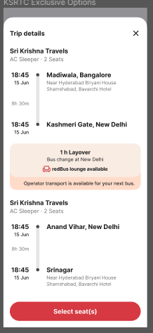

Seat Layout use cases:
- Seat layout will have 2 tabs for each leg of the journey like shown
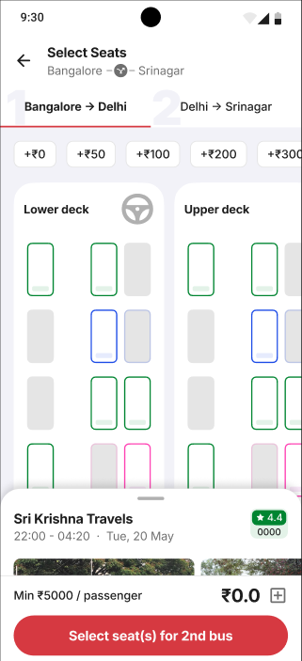

- User should be able to navigate between both these tabs
- The following flow should be allowed:
User selects seats for the 2nd leg > user selects seats for the first leg > proceeds to BP, DP screen
- Price: User would see incremental price for each seat like shown in the price ploys
Example:
First service seat price - 1) 300, 2) 400, 3) 500
Second service price - 1) 500 2) 700 3) 800
- User would see 800 as the fair on the SRP
Seat price in first bus would be 0,100,200 and second bus would be 0,200, 300 respectively
- Bus details section for each of the leg would have the bus details for the respective service
- In case user selects unequal number of seats on the seat layout, throw an error when user tries to proceed to BP/DP screen
- Price breakup to show the price break ups for both the legs like shown
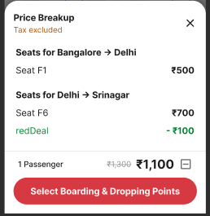
- Wherever applicable - On the expansion of bus details, we would also show the communication around bus being non reschedulable and non cancellable like shown:
(Please note that the user cancellation would be allowed in connecting services)
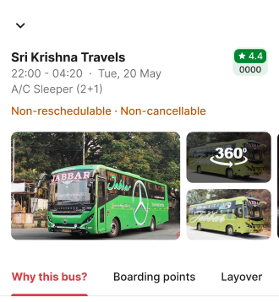
- Regarding layover component in bus details:
  - In case in the layover city, BP and DP are the same then:
Layover details would appear on both of the bus details like shown
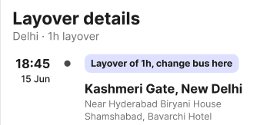
  - In case in the layover city, BP and DP are different - the layover component would appear like shown:
In case commute would be provided by operator, we would call that out in the layover section

We have 3 variants of layover component in the bus details:
1. Dropping point of 1st leg = Boarding point of 2nd leg
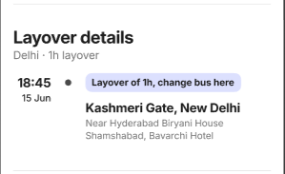

2. Boarding point and dropping points are different, commute is not provided by the operator
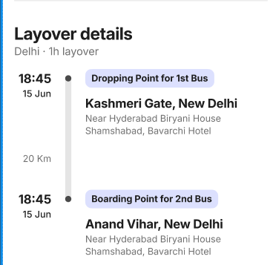

3. Boarding point and dropping points are different, commute is provided by the operator
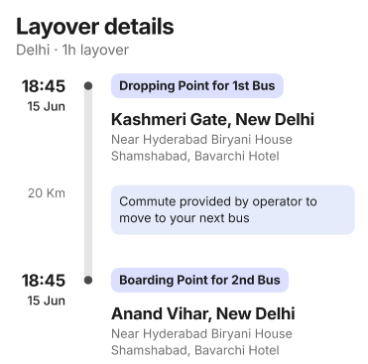
- (Subject to GDS providing these details: Bus details meta to contain lounge images in case of connecting services)

BP DP selection screen
- We will call out Source and destination names right below boarding and dropping points as shown
- We would also highlight the layover duration on this screen like shown
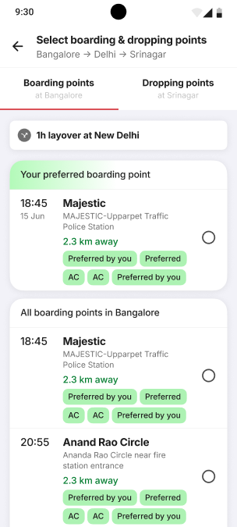
- Click on layover component should open a bottom sheet like shown:
(whichever case is applicable should be shown among the 3 below)
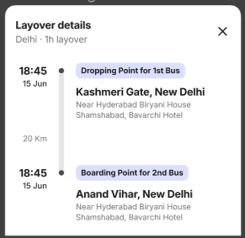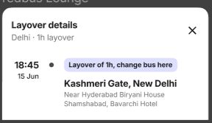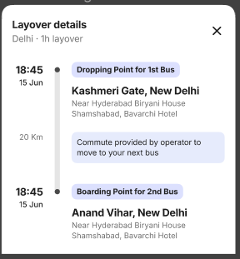

Cust Info
- The top component describing journey details would change to accommodate
  - BO name
  - Layover duration & place
  - Boarding point, time
  - Dropping point, time
  - Number of seats selected
  - View details CTA
  - Non reschedulable & non cancellable bus tags
Like shown:

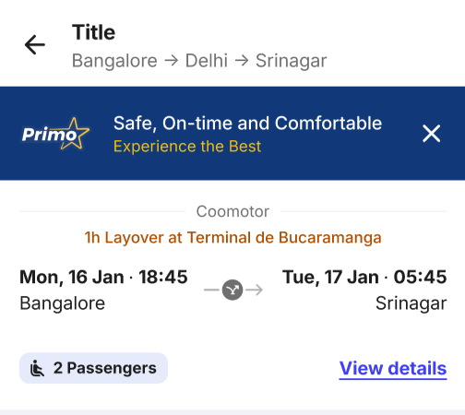

- Click on view details CTA would open this bottom sheet:
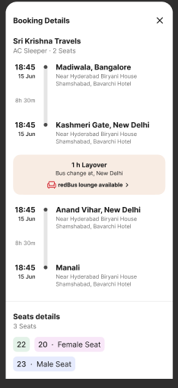

- Seat selection related use cases:
  - In case user has selected 2 seats:
Bus 1: 1 female, 1 general
Bus 2: 2 general seats
In this case we must ask the user to select at least 1 female seat on cust info
- In a similar manner, contradictory selections must not be allowed
Example of contradictory selections:
Bus 1: 2 reserved for male seats selected
Bus 2: 2 reserved for female seats selected
Details are listed here: Connected services: Gender use cases
Please note that the cases highlighted here are for 2 seats, but the logic must extend for any number of selections.

Payment Page

- The booking details component will contain
  - Source
  - Destination
  - Boarding time, date, day
  - Number of add ons selected
  - View details CTA
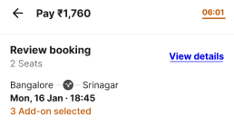
- Clicking on view details would expand the bottom sheet like shown
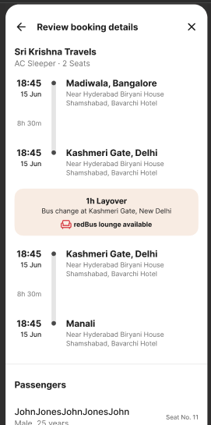
- Just like today - the GST will go to the state mentioned by the user in the cust info flow

Post booking / thank you

We would be taking up the post booking changes as a part of phase 1 itself.
Thank you page would be as shown below. It would have 2 different live tracking cards like shown in the designs
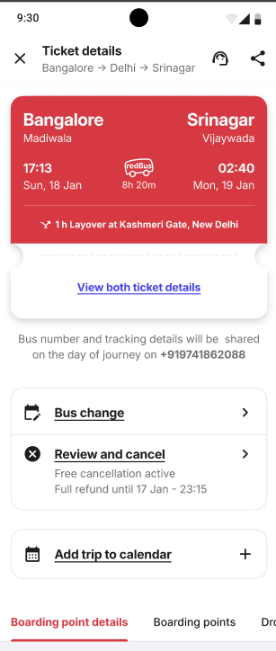

- The main ticket page should highlight the ticket form A-C
- Click on view both tickets should open Leg 1 ticket - swiping on which should open the leg 2 ticket like shown. The ticket # and PNR number shown here should be for individual tickets
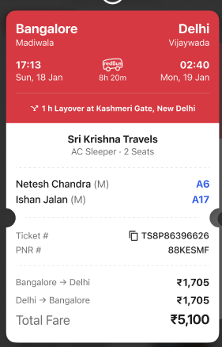

My bookings & Bus Buddy
- We would now have a tuple in my bookings which will call out ‘A-C’ service

Tickets & communication:
- Whatsapp communication
We would send out one consolidated communication with eticket
- Email communication
We would send out one consolidated communication for eticket
- Ticket PDF
Ticket PDF would have consolidated view like shown:
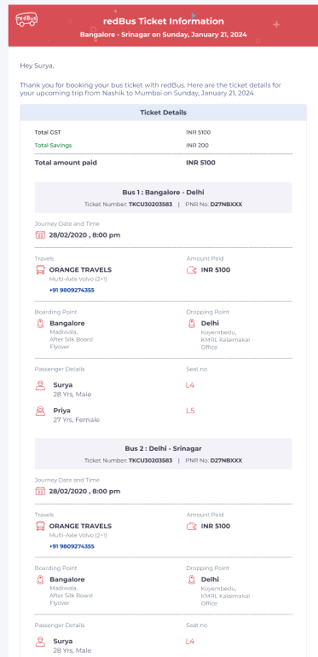

Cancellation Flow:
- Connected service (A-C) & individual services (A-B, B-C) will have the same cancellation policy
- The connected service hence would be cancellable
- Cancellation for only 1 leg in the journey would not be allowed
- Partial cancellation (no of pax) won’t be allowed
- Cancellation flow would be as shown:
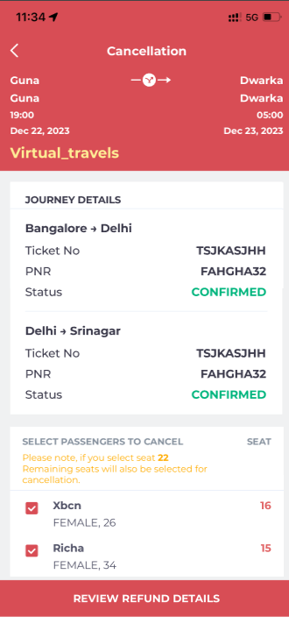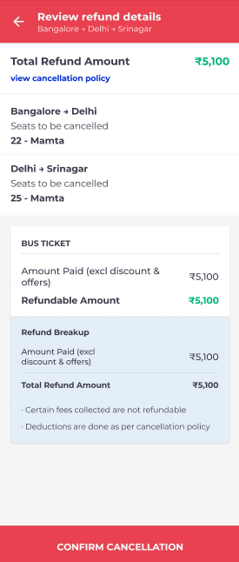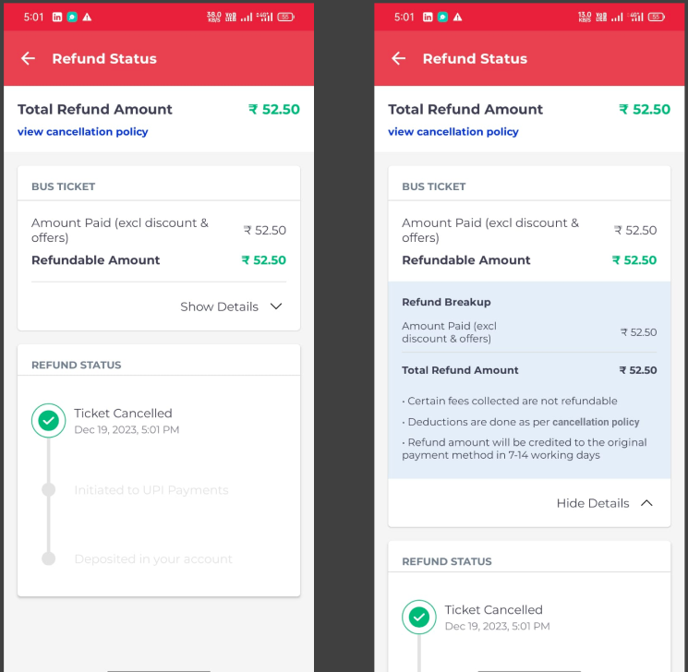

Bus cancellation from BO
As confirmed by BITLA, bus cancellation from the GDS will not be allowed for a single bus if the bus is a part of the connecting service.
Hence the operator and the user will settle their transaction offline.

Hence there won’t be a case when user boards the first bus and the second bus gets canceled.

Date change flow:
- Reschedule would not be supported

Self Help

- We will treat two legs of the journey as two different tickets for Phase 1
- Ticket cancellation - Should cancel both the PNRs and get refund details accordingly from Neo
- Restrict reschedule for connected services tickets - update prompts
- FAQs on Self Help
- Self help to contain layover information along with other information
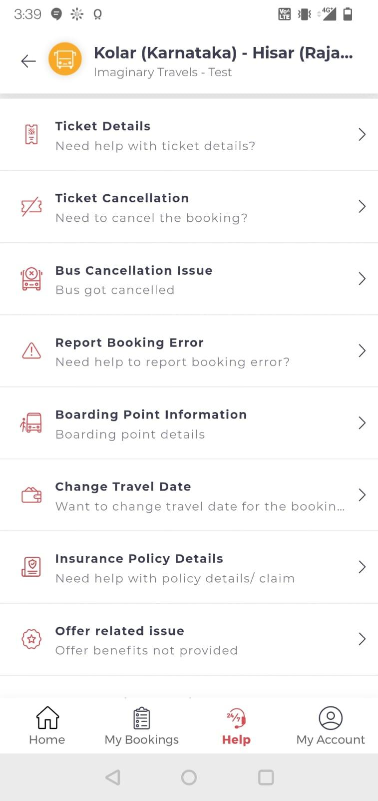
- In ticket detail, meta about layover (city and duration) needs to be added
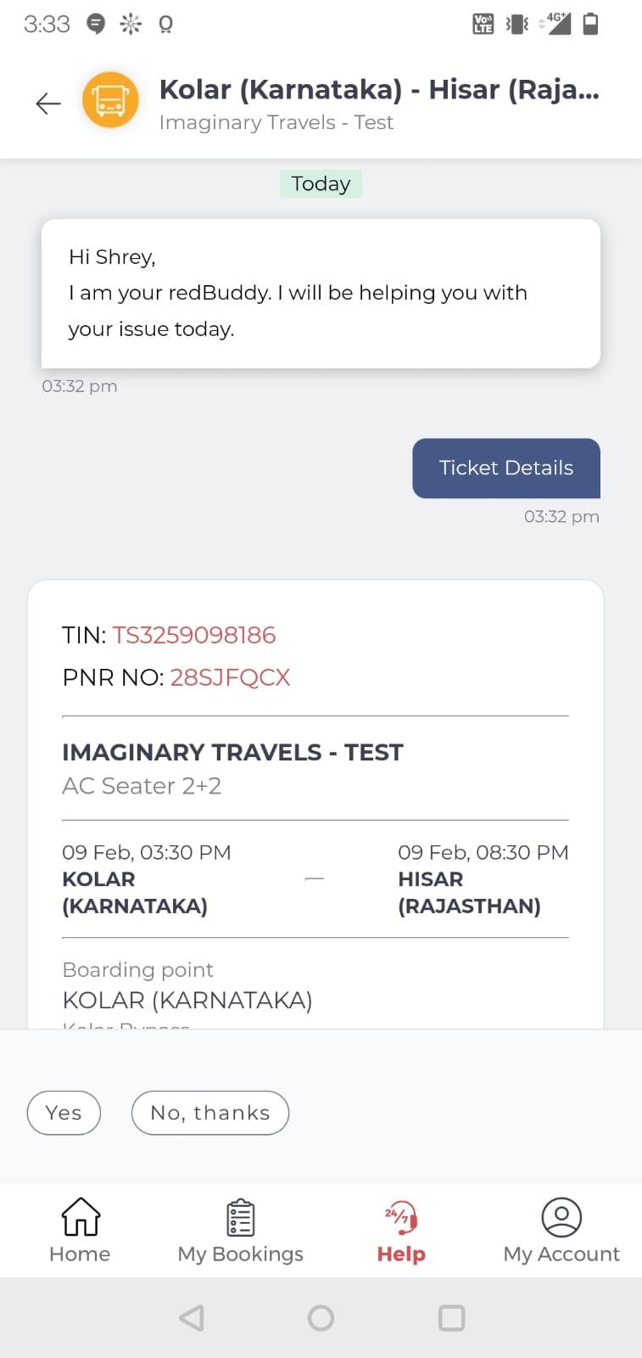
- Cancellation reasons to include ‘I did not know that this was a connected service
- Update design to show both the legs in a single tile & then flow to select the specific service from connected services booking on self help

CRM / IVR

- CRM
  - Visibility of the connected services transactions / flag for agents (P0)
    - Show primary tin & sub tins & allow search on all 3 if applicable
    - Map all cases against primary TIN
    - Bus cancellation - Cancel for both legs along with co passengers
    - Ticket cancellation - Should cancel both the PNRs and get refund details accordingly from Neon
    - Exceptional refund will be for specific leg for phase 1
  - FAQs for Agents (P0)
- IVR
  - Restrict cancellation & Reschedule - Update IVR prompts (P0)
  - Get connected services transactions on IVR transaction prediction (P1)
  - Update flows to select a specific service from connected services on IVR (P1)

Please find the answers to queries asked by the CRM team here:
Connected Services- Questionnaire

Ratings & Reviews (WIP)
- We need to capture the ratings and reviews for one entire connected service
- No change in the flow in which we would capture the rating
UGC Scope - UGC: connected Services

tripRewards and connected services

Connecting services and tripRewards WILL exist together

Case 1 - Pre redemption

- The connected service will be considered as 1 ticket for streaks. Meaning, in case user books a connected service, the streak progress would take 1 step forward
- Boarding time of the 1st service would be considered as the boarding time for the connected service
- SD, DOJ check would work on the (final source, final destination, DOJ of 1st leg)

Case 2 - Redemption flow

- User should be able to redeem the free ticket in connecting service
- Amount should be deducted from the overall ticket amount
- Connecting service ticket should be considered as a single one
- Cancellation and rescheduling rules of tripReward will be applicable here as it is.

Tracking
We need to track the following in MRI tables:

What we need to track:
- # of services connecting configured (Omega)
Dimensions: S, D, DOJ, Bus types
- A flag for a connecting service in mri_srp_items
- # of bookings in connecting services (neon_ind_tickets_event)
Dimensions: S,D, DOJ, Channel of booking,
- A flag for connecting service in mri_confirmorder,

Add ons

  - User will NOT see any add ons like RAP / insurance

redDeals

- If the redDeal is applied from A to C - then we can show it on the SRP
- If not then
  - Amount in SRP should be shown net of redDeal
  - There would be no redDeal representation across the funnel
  - This includes SRP, SL, payment
  - If the operator has configured return trip redDeal across A to B / B to C or A to C - it should not be shown to the user

In case when the user chooses 2 or more seats on each of the legs - how to make matches/ combinations of the seats?
- We will arrange the seat by high price to low price
- Match the highest price with highest price & lowest with lowest price
- In case the price of the two seats is the same - match any one randomly

GA Tracking

Edge cases

In case user tries to cancel the ticket from ‘Cancel my ticket > Enter PNR > Cancellation’ flow which is present in web and mweb,

We should treat that PNR as the connected PNR

Live tracking related use cases:

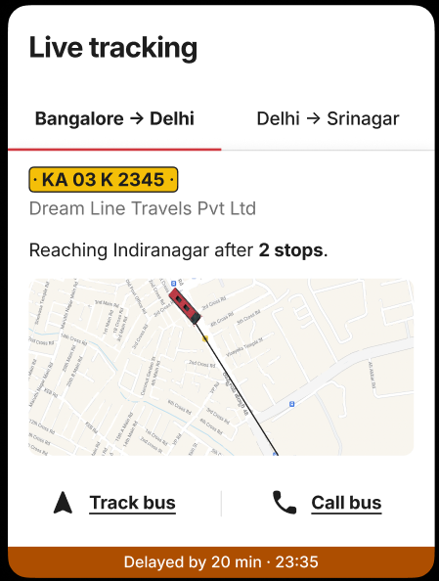

Case 1: If layover duration < 3 hours then:

When to show dual live tracking screen like shown above:
- User should see just 1 live tracking available (for leg 1) till (Leg1 dropping time - 2 hours)
- User should be able to see dual live tracking screen from:
(Leg1 dropping time - 2 hours) to (Leg1 dropping time + 2 hours)
User must not see a dual live tracking screen if the time does not fall in the above window

During the window mentioned above, which screen to show upfront?
- User should see 1st leg live tracking upfront until (Leg 2 boarding time - 30 min)

Example:
1st leg dropping point = 8 am
2nd leg boarding point = 9 am

- User would see just 1 live tracking screen, for first leg till 6 am
- 6 am to 10 am both live tracking screens would be available (dual tracking screen)
- 6 am - 8:30 am user would see a dual live tracking screen with 1st leg tracking shown up front
- 8:30 to 10 am user would see a dual live tracking screen with 2nd leg tracking shown up front
- Post 10 am user should only see 2nd leg live tracking screen

Case 2: If layover >= 3 hours

- Only show 1 live tracking screen at a time. No dual live tracking must be shown
- 1 st leg live tracking should be shown till 1st dropping time + 1 hour
- 2nd leg live tracking screen should be shown from 2nd boarding time - 1 hour

Pending items:

- Live tracking, talk to Gaja
  - Reschedule option should be greyed out instead of not giving it at all
  - Cancellation message is unclear
If one passengers ticket is canceled - all tickets will be canceled
  - tripReward designs in bus details
  - On SRP - should it be From <price>? OR <Price> onwards
  - How will strikethrough work when we have a redDeal? As stikethrough and ‘Onwards’ occupy the same place Richa Gupta to add
  - Fare breakup, add Tax included/ excluded placeholder, redDeal should be on A-C level, title is missing for the bottom sheet
- Pre journey messages should be 1 or 2
- Nudges should only come on A-C level, not on leg level

Design inputs needed

- Reschedule option should be greyed out instead of not giving it at all - Will be as per current implimentation no additional input Required
- Cancellation message is unclear - This is as per existing production implementation, no additional input required
If one passengers ticket is canceled - all tickets will be canceled - This is as per existing production implementation, no additional input required

- tripReward designs in bus details - no changes here
- On SRP - should it be From <price>? OR <Price> onwards - onward
- How will strikethrough work when we have a redDeal? As stikethrough and ‘Onwards’ occupy the same place
Onward and strikethrough positioning in SRP needs to be discussed. (Is it updated already as part of redDeal enhancement?)
- Fare breakup, add Tax included/ excluded place -Tax excluded and included already there in design in cust info
- The header is different in SRP for iOS and Android - Updated
- Price breakup in seat layout:
a. Title is missing in android
b. Price breakup when seat for one of the leg is selected
c. The offers like redDeal shown in design looks like it is part of the second leg.
- Header for cancellation is different for android and iOS
In Review And refund details, subtitle is “Bangalore - Delhi - Srinagar” in case of android.
In the case of iOS, some say “Bangalore - Delhi - Srinagar” and one says “Gune-Dwarka 22 May” Should date be part of the subtitle? Should it be A-C? Or A-B-C?

Templates

Whatsapp:

Dear *{{NAME}}*,

Your bus booking from *{{SOURCE}}* to *{{DESTINATION}}* is confirmed with *{{TRAVELS}}* for *{{DOJ_MMMM_DD_YYYY}}* at *{{DEPARTURE_TIME1}}*.
You will have a layover in {Layover city} for {layover duration} hours.

*Here are the details*:

*Ticket No.*: {{TIN}}
*Passenger(s)*: {{NAME}}
*PNR*: {{PNR}}
*Bus 1 seat number(s)*
{Source} to {Layover city}: {{SEAT}}
*Bus 2 seat number(s)*
{Layover city} to {Destination}: {{SEAT}}
*Boarding point*: {{BORDING_POINT}}
*Address*: {{ADDRESS}}
*Boarding point contact*: {{CONTACT_NO}}

*For any queries, contact redBus Support*: https://www.redbus.in/info/redcare

{{PROMOTION_TEXT}}

This M-ticket can be used as proof of your booking. By not printing the ticket, you make the world a greener place!

*Team redBus*

Please note that in case the duration is < 30 mins , we need to skip the yellow highlighted part in the above template.
In case the duration is > 30 mins, always round down {layover duration} and keep it a multiple of 0.5 hours

- CS ticket without layover
(Don’t include the yellow line)
- CS ticket with layover
(include the yellow line)

